Nutrition Analysis Using Image Classification

**ABSTRACT**

In the current age, people are more conscious about their food and diet to avoid either upcoming or existing diseases.In order to properly assess dietary intake, accurate estimation of calorie value of food is of paramount importance.Due to the advances in various technologies used in smart phones, their computational power has also increased.They are capable of processing real-time multi-media information with their computational power. Since the present smart phones can handle the high-quality images too, research on food classification is focused on developing real-time applications which capture images and train the machine learning models instantly.It helps to take prevention to avoid diseases such as diabetes, blood pressure and so on.

### 1.INTRODUCTION

### 1.1 OVERVIEW

Over the past few years, obesity has become a serious problem.Obesity is associated with many of the leading causes of death,such as diabetes,heart disease,stroke and cancer. The most effective way to prevent obesity is through food intake control,which invovles understanding food ingestion,including the nutrients and calories of each meal.To assist with this issue ,This study develops a nutrition analysizer that can analysize the composition of a food based on a provided image, allows users to conveniently and quickly understand the calorie and nutrient intake with the aim of controlling diet and balancing nutrition.

**1.2 PURPOSE**

The main purpose of this project is to produce instant nutrition information to the user with the web-based nutrition analyzing software.

**2.Literature Survey**

**2.1 Existing Problem**

As it is not always not easy for a person to remember the actual contents as well as the amount of the food intake. In addition, to see an expert every 24 hours is difficult and, in many cases, not feasible. In fact, the great majorities of existing clinical methods are similar to this and typically require food records to be obtained for 3 or 7 days, with 7 days begin the “gold standard”. The problem with this manual approach is obvious: people not remembering exactly what they ate forgetting to take note, and neglecting to see expert dietician in a very frequent basis.

**2.2 Proposed Solution**

Here effort has been made to classify the images of food for further diet monitoring applications using convolution neural networks (CNNs). Since the CNNs are capable of handling a large amount of data and can estimate the features automatically, they have been utilized for the task of food classification. The standard Fruits dataset has been selected as the working database for this approach. After the classification is done a Nutrition API is called to get the calorie count and protein content. A Web application is built and CNN model is deployed to use this application.

**3.Theroritical Analysis**

Convolutional Neural Network (CNN) is class of deep neural network popularly used for visual data analysis. This visual data can be in the form of images and videos, CNNs are inspired by the mammalian visual cortex. They were developed as computational model for natural visual perception.

CNN is used to solve a wide range of visual tasks such as image classification, object detection and may more. CNN consists of series of convolutional layer with nonlinear activation functions and some down sampling layers. These CNN are able to capture hierarchical patterns and produce image representation.

A convolutional neural network takes an input image, performs a series of operations on it and then classifies it under certain categories (Example: Fruits, Animals). The result can vary depending upon the type of problem we are trying to solve. In the case of image classification, we get a label (probability score).

Let us see what is Neural Network

Artificial Neural Network, usually called neural networks, are interconnected systems composed of many simple processing elements operating in parallel whose function is determined by network structure, connection strengths, the processing performed at computing elements or nodes.

Following is the structure of Artificial Neural Network:

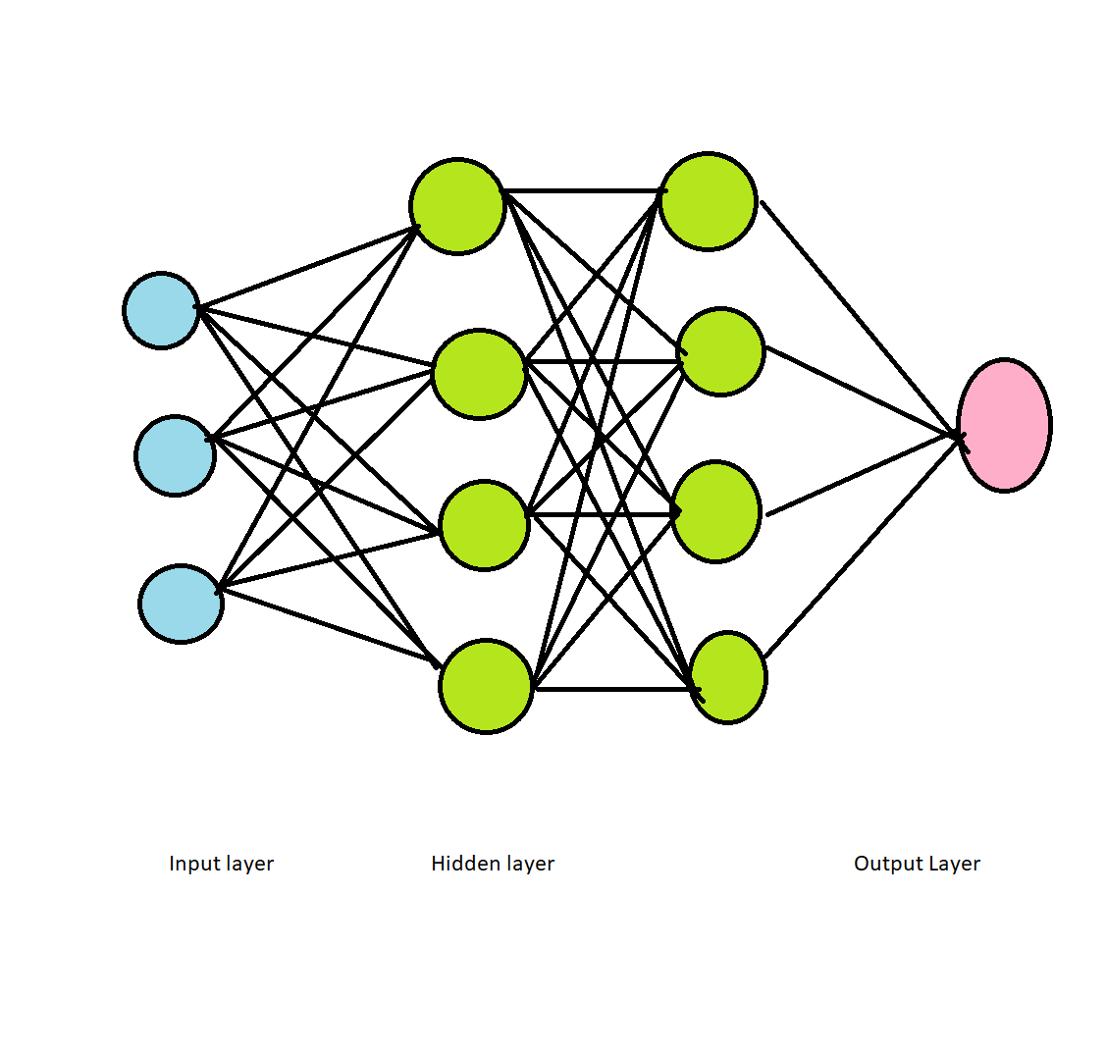

**ARTIFICAL NEURAL NETWORK**

This name and structure are inspired by the human brain, mimicking the way that biological neurons signal to one another. Artificial neural networks are comprised of a node layer, one and more hidden layers and an output layer. Each node, or artificial neuron, connects to another

**Why convolution?**

* Convolution is a simple mathematical operation between two matrices in which one is multiplied to the other element wise and sum of all these multiplications is calculated.
* (f * g) (t) = integration of –infinity to infinity f(x) * g(t-x)

F (image) g Feature Detector f * g Feature Map

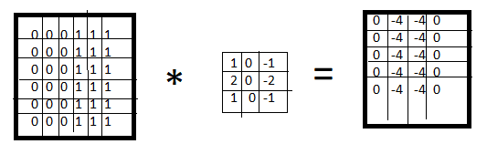

* Convolutions are performed for various reason:
* Convolutions provide better feature extraction
* They save a lot of computation compared to ANNs
* Less number of parameters are created than those in pure fully connected layers.
* Due to a smaller number of required parameters, lesser fully connected layers are needed

**Convolution Layers**

In a CNN, the input is a tensor with a shape: (number of inputs) x (input height) x (input width) x (input channels). After Passing through a convolutional layer, the image becomes abstracted to a feature map, also called an activation map, with shape: (number of inputs) x (feature ap width) x (feature map channels). A convolutional layer within a CNN generally has the following attributes:

* Convolutional filters/kernels defined by a width and height

The number of input channels and output channels. One layers input channels must equal the number of output channels of its input.

**Image Data Generator:**

Image data augmentation is a technique that can be used to artificially expand size of a training dataset by creating modified size of images in the dataset. The keras deep learning neural network library provides the capability to fit models using image data augmentation via the Image data generator class

For image classification we use convolution neural network

This is very important step in our deep learning model building process. we have to define how our model will look and that requires

* Importing libraries
* Initializing the model
* Adding CNN
* Anding Dense layers

CNN Layers

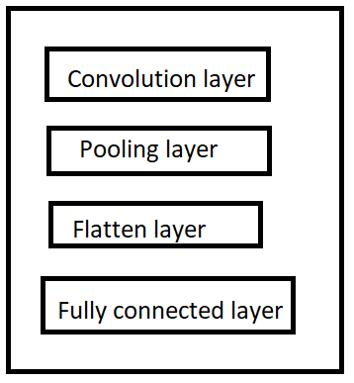

Pooling layer:

Another important concept of CNN is pooling which is a form of nonlinear down sampling. It will extract location of a feature is less important than its rough location relative to other features. This is the idea behind the use of pooling on CNN. The pooling on convolutional neural networks the pooling layers serves to progressively reduce the spatial size of the representation, to reduce the number of parameters.

Convolutional network may include local/global pooling layers along with convolutional layer. Pooling layers reduce the dimensions of data by combining the outputs of neuron clusters at one layer into single neuron layer. There are two types of pooling in popular use: max and average. Max pooling uses the maximum value of each local cluster of neurons in the feature map while average pooling takes the average value.

**Max Pooling**

Extract the main features perfectly

Feature MapMax pooling

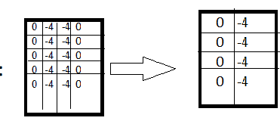

**RELU Layer**

RELU is the abbreviation of rectified linear unit, which applies the non-saturating activation function

F(x) = max (0, x). It effectively removes negative values from an activation map by setting them to zero. It introduces nonlinearities to the decision function and in the overall network without affecting the receptive fields of the convolution layers

**Flattening Layer**

A Flatten layer in keras reshapes the tensor to have a shape that is equal to the number of the elements contained in the tensor. This is the same thing as making a 1D array of elements.

Max pooling single dimensional array

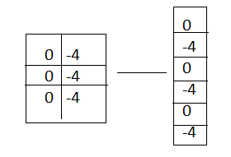

This single dimensional array is given to fully connected layer it is also called as Artificial neural network.

**3.1 block diagram**

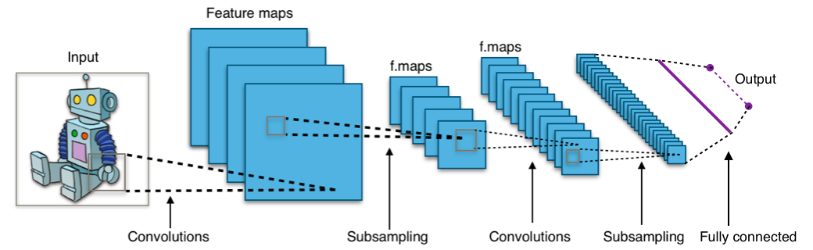

**CNN Architecture**

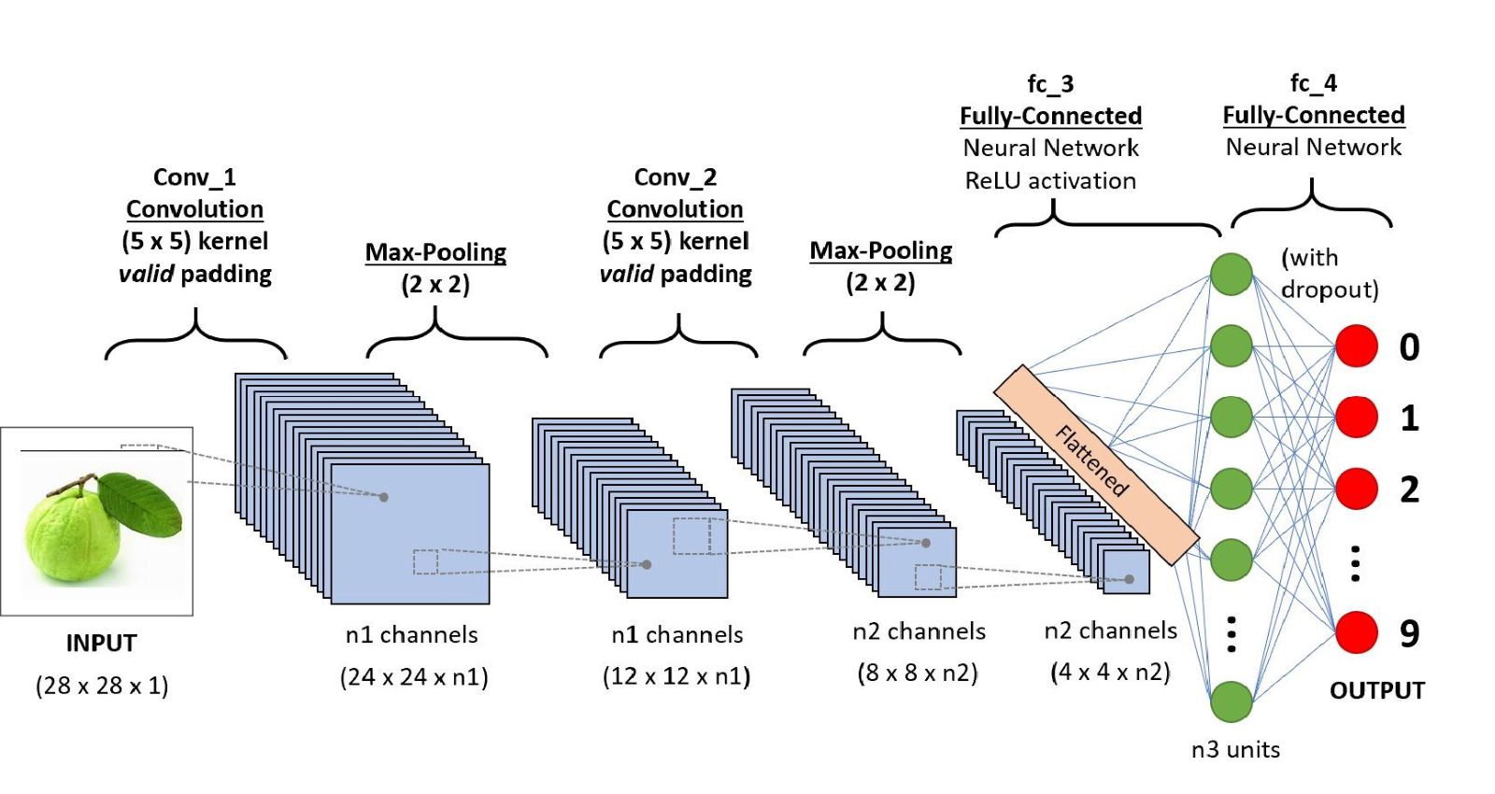

Block diagram of CNN for proposed method for fruits dataset

**4.Experimental investigation:**

Before starting this project, a research is made how nutrition are important and why people should aware of their food intake. And a model test is performed with different type of images to check the resultant result is correct or not.

Durning investigation I researched how many calories are present in 100grams of my fruit dataset.

|  |  |  |
| --- | --- | --- |
| fruit | grams | Real values in calories |
| orange | 100grams | 47 |
| apple | 100 grams | 52 |
| guava | 100 grams | 68 |

**5.Flow Chart**

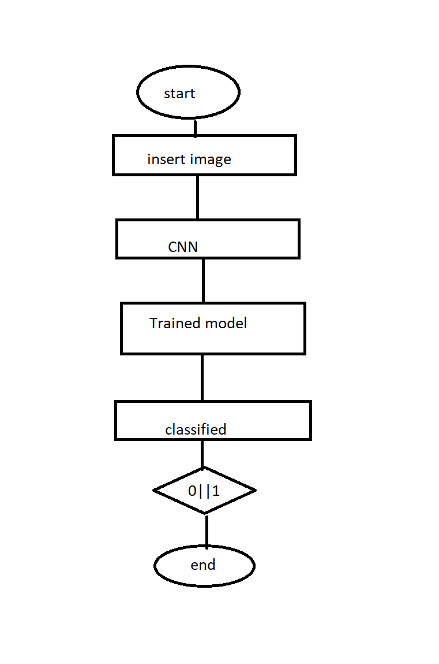

**Flow chart of image classification**

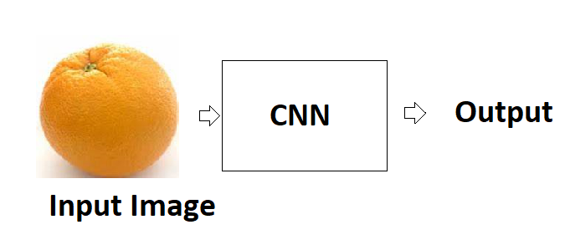

**Convolution neural network**

**6.Result**

After Training and Testing the model with 3 different types of fruits, When the user uploads an image, the model will load the image

And converts the image into one dimensional array that is 1’s or 0’s format. Nutrition values of the uploaded image will be displayed on user interface. Nutrition values are extracted using Rapid API.

**7.Advantages and Disadvantages**

* This model reduces the risk of some diseases including heart disease, diabetes, stroke cancers etc.
* Consulting dietitian is not always possible this web-based application helps to know nutrition's in a food if user upload a food image from wherever they are.
* Web based system model of my project (Nutritional Analysis Using Image Classification) will provide information on what they are putting in their body by reading the nutrition facts.
* People with diabetes it is ideal to maintain a healthy weight.
* At present this model is limited to few fruits. It will not display nutrition values of meal or food that is not present in the dataset. user may upload image that is not present in my dataset may not identify the image and give false result.
* At present this system will also identify one fruit and allows user to upload only one image.

**8.Applications**

* Nutritional analysis using image classification system is used by the dietitians who wants to maintain their health.
* This system is also useful for patients who is suffering from lack of nutrition's.
* Nowadays due to corona pandemic, People are staying at home they may unaware of their food intake. This may increase or decrease nutritional values in their food.

**9.Conclusion**

In this report, I described the development of nutritional analysis using image classification system for tablet, mobile devices. As I indicated, measuring accurate dietary intake is an open research problem in the nutrition and health fields. I feel I have developed a tool that will be helpful for replacing the traditional food record methods and to help patients suffering from nutrition.

**10.Future Scope**

* In the future, I would like to increase the dataset with more images to improve accuracy and decrease loss.
* Further this system will be developed to identify different ingredients of a meal or from set of fruits.

**11.Bibligraphy**

1.whole: Rethinking the science of nutrition by T. Colin Campbell, PhD with Howard Jacob, PhD.

2.Deep learning with python- written by mark graph.

3. Shape Analysis and classification (Theory and Practice) written by Lanciano Da

Fontoura Costa, Roberto Marcondes Cesar jr.

**12.Appendix**

This CNN model shows that I got significant accuracy in image classification when supplemented with location information, and in this case, it would do very well classifying the fruit images. I am able to archive over 80% accuracy combining all of the features. Images in these datasets are of different angles. While the results are good, it is important to realize that limitations of the accuracy reported in this project.

**12.1 Source code**

Trained Model source code

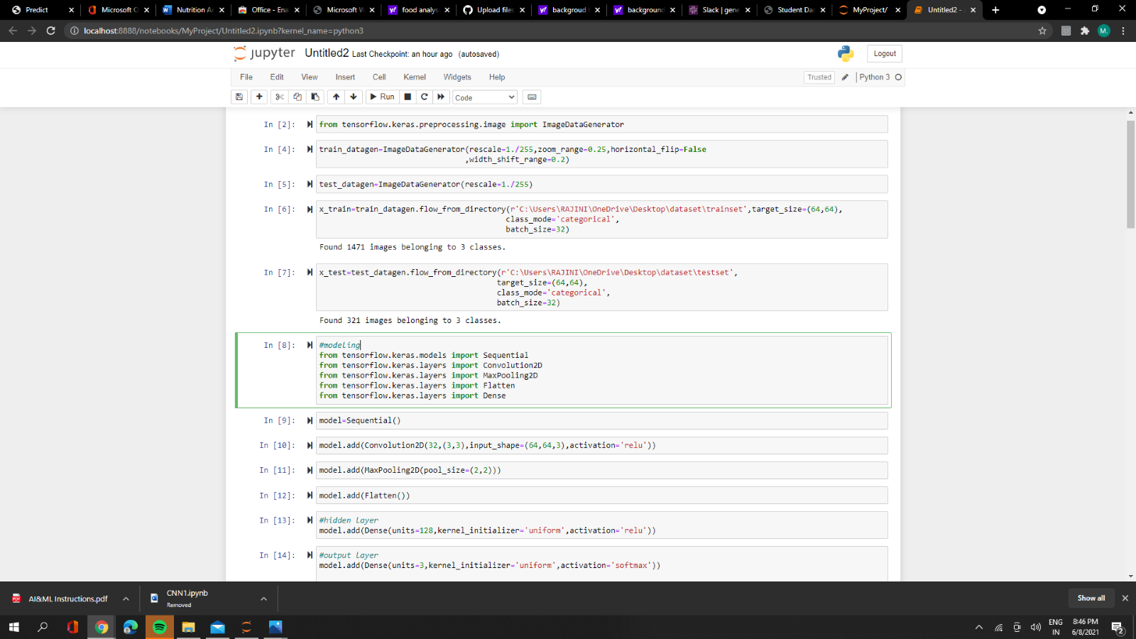

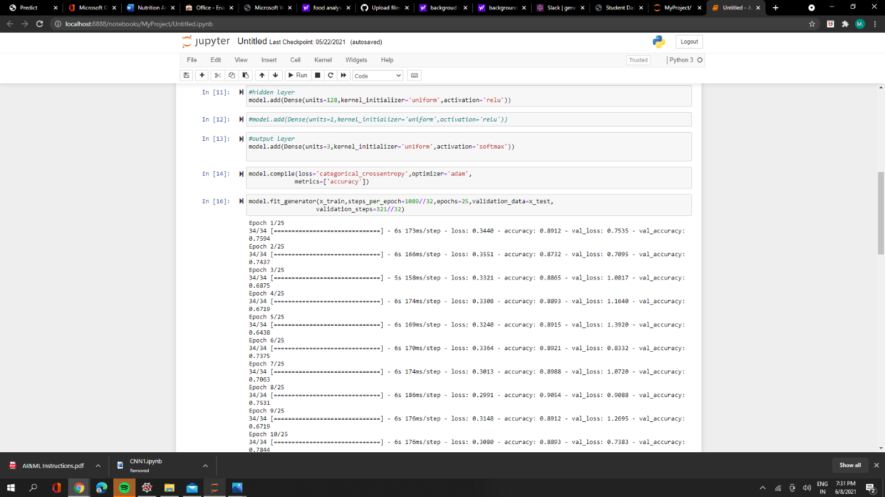

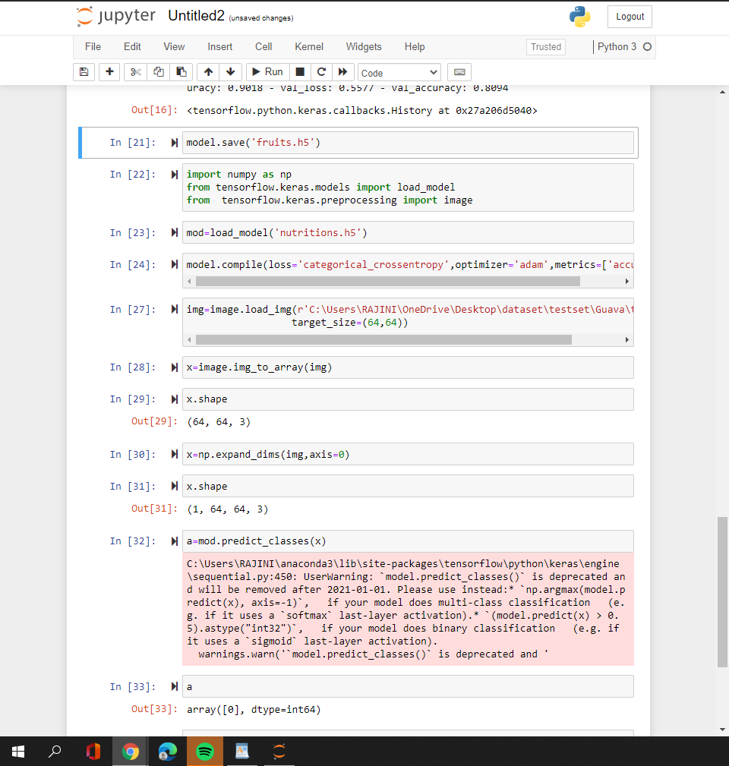

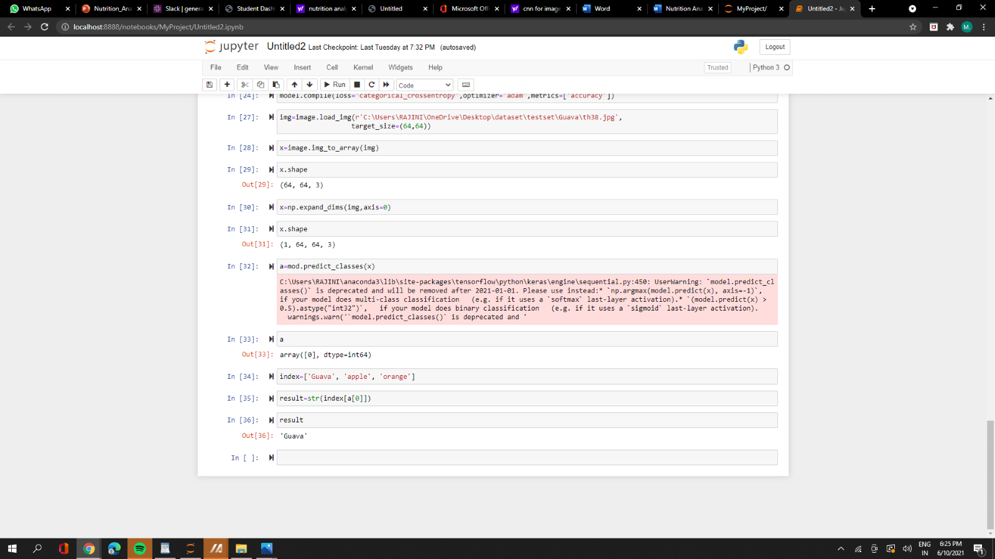

**12.2 UI output screenshot**

